Resume
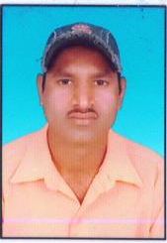

SANDEEP KUMAR JAIN
Gali no.4 Dhierasah Nagar
Ratlam (M.P.) 457001
Mob. No.9669902310

Career Objective

- I look forward to associate my self with an organization, where there is an opportunity to share, contribute and upgrade my knowledge and development of self and organization served.

Educational Qualification

s.no. | Eduacation | Month | Year | Maximum | Minimum | %
10th | MP Board Bhopal | MAR-APR | 2001 | 500 | 300 | 60%
12th | MP Board Bhopal | MARCH | 2003 | 450 | 270 | 60%
B.COM | Vikram University Ujjain | MAR-APR | 2007 | 1800 | 867 | 48.16%

Other Qualification

- Basic Computer Knowledge.

Personal Details

Father’s Name : Mr. Parasmal ji Jain

Permanent Address : Vill. – Nagra
Dist. - Ratlam (M.P.)

Date of Birth : 26th Dec 1985

Marital Status : Un Married

Nationality : Indian

Languages Known : Hindi & English

I here by declare that the above mentioned information is authentic and up to date to the best of my knowledge.

Date: -

Place: - Ratlam [SANDEEP KUMAR JAIN]

